**INTEGRATION TESTING**

**Module:**AdhocTicketDAO.java

**Tester:** Santoshi Rupa Gupta Chittimilla

Implemented Class:

IAdhocTicketDAO.java

Number of methods: 5 and one constructor

Tested Status:

|  |  |  |  |
| --- | --- | --- | --- |
|  | | **Testing Status** | **Bug** |
| **Modules** | AdhocTicketDAO.java | Done | 15 |
| **Implement Class** | IAdhocTicketDAO | Done |  |
| **Import Classes** |  |  |  |
|  |  |  |  |

**Error Screenshot in command mode**

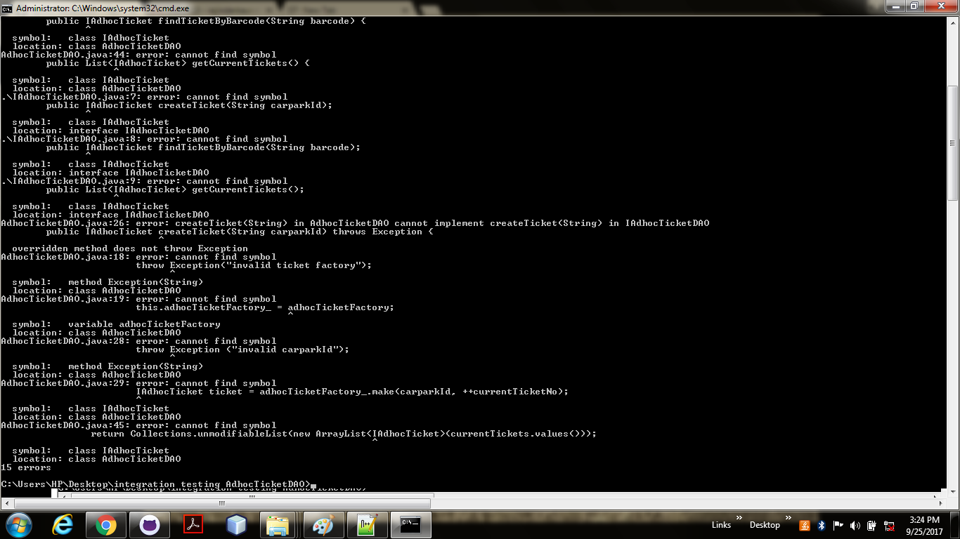

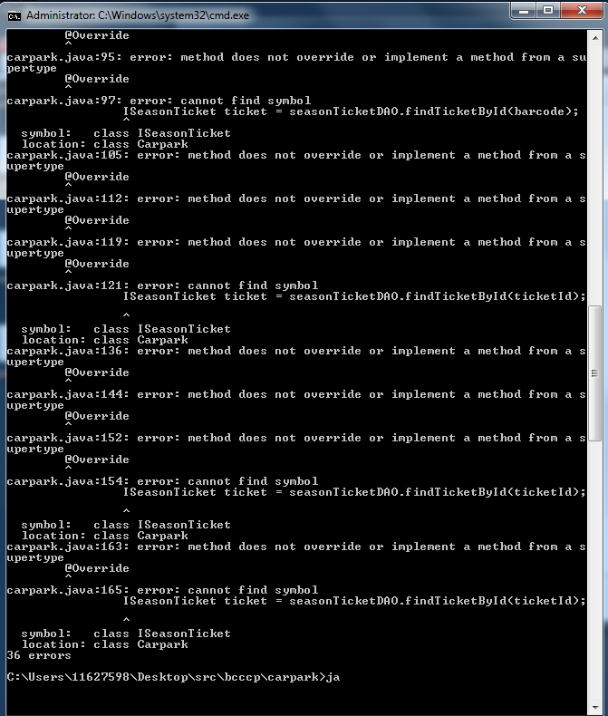

**Carpark.java**